(Approx. 1260 words)

New Programs and Devices
By Dick Maybach, Member, Brookdale Computer Users’ Group, NJ
November 2016 issue, BUG Bytes
www.bcug.com
n2nd (at) att.net

Computer programs can be complex and learning to use a new one can be difficult and frustrating.
Further, many hardware devices contain processors, making it easy for designers to add features that can make them equally complex. My primary operating system is Linux, and I like to explore new applications. These are usually free, and there are often several for every task, usually with drastically different approaches. I also love such gadgets as digital cameras and pocket GPS navigators. As a result, I am continually trying to master new programs and devices and have worked out some methods of doing this.

There are many barriers that make the task difficult.
- Every designer has a different idea of how a program or device should work, and trying to use a new one the same way you used an old one can be counter-productive. Sometimes, the most difficult part is unlearning what you think you know, especially for experienced users who may feel they should be able to figure out new software and hardware by instinct.
- Different products can use different vocabularies – for example “uploading” sometime means importing information into an application and sometimes exporting it.
- Except for a handful of very popular applications, good tutorial books don't exist. This is especially so for Linux, OS X, and many cameras.
- The number of brick-and-mortar bookstores is decreasing, and those remaining are continually decreasing the shelf space for technical books. Software is frequently updated, meaning that books quickly become outdated and public libraries can't keep up. As a result, it is difficult to find useful information by browsing books.
- Information on the Internet is fragmented, poorly organized, and often wrong.
- Tech writers seem to fixate on tasks that don't interest me – they go into elaborate detail on things I never do and skip over those I perform almost every day.
- User interfaces are frequently not well designed, and not all products have useful help features.
- Purchased software and hardware usually includes only a small printed pamphlet, containing mostly legal disclaimers in several languages and labeled, “Getting Started Guide,” or something similar. Many people assume this is the manual and never look at the real manual, which resides on an included CD-ROM or the vendor's Website.

I have found several ineffective techniques.
- Calling a friend – while this is occasionally appropriate, you will soon run out of friends if you overuse it, and some friends have more confidence than expertise.
- Taking random screen shots – unless you organize these and add comments as soon as you take them, you just end up with directories full of useless graphics.
- Handwritten notes – unless you organize these you end up with stacks or useless paper.
- Working by analogy from similar products – every program is different, and few are clones. New ones appear because their developers felt previous ones had fundamental shortcomings; few are just old ones with bug fixes.
- Using a new program to work with valuable data – making a mistake here could mean you lose the data.

Before you install the software or turn on the device, gather the available information about it that appears useful, including: the full manual (if only an on-line version is available, get its URL) not just the getting started guide, reviews (which frequently provide helpful overviews), and Internet articles (or their URLs). If this is software, make a complete backup of your computer. This is important if you downloaded the software, especially for Windows users. Linux users can install new software on a virtual machine, which isolates any problems. Read the reviews and articles you gathered and at least the introduction and installation sections of the manual. Create a sandbox in which to experiment. This can be as simple as a directory with a few files you will manipulate with the new software or as complex as a virtual machine. Set up means of recording notes. I use CherryTree, http://www.giuspen.com/cherrytree/, which is free, but available only for Linux and Windows; Mac users can find equivalents athttp://alternativeto.net/software/cherrytree/?platform=mac. Screen 1 shows my complete CherryTree notes on QMapShack after an hour or so of use. (This is a mapping program that works with a GPS.) As you can see, these fit on a single page, and at this point I had a lot yet to do.

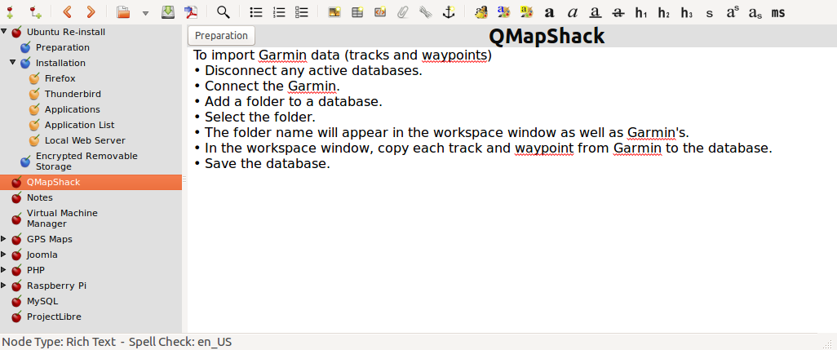
Screen 1. Initial CherryTree Notes on QmapShack.

By contrast, Screen 2 shows a portion of my notes on installing Ubuntu Linux, which have been refined for several years. Note from the outline view in the left panel that these now extend over several pages. I modify these notes again with every new installation.

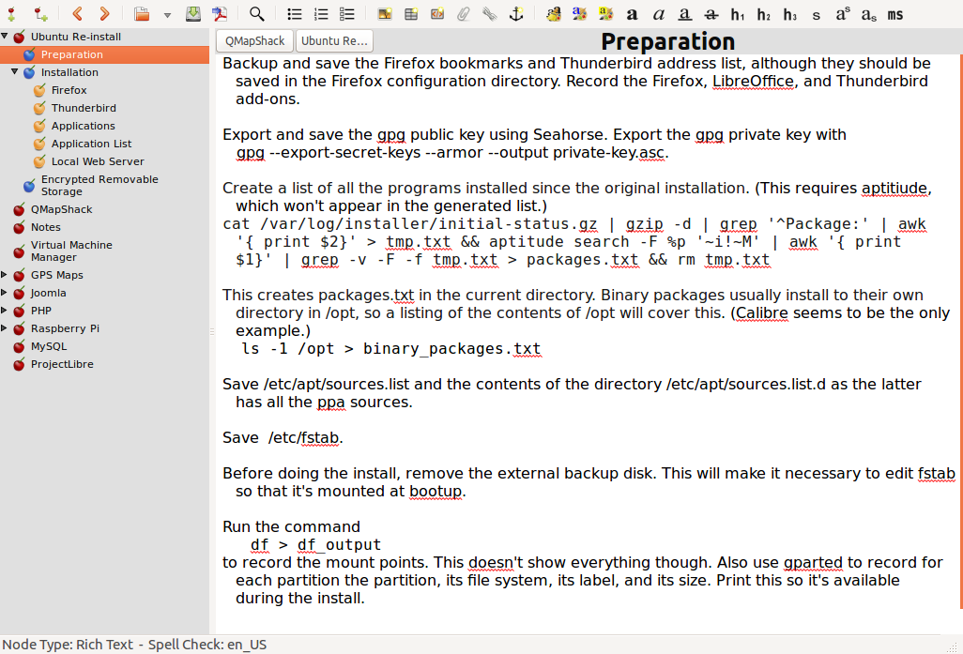
Screen 2. CherryTree Notes on Ubuntu Linux.

Now you're ready to begin. Open the manual, or equivalently open its file or URL on your desktop, and open your notes program. As a result, you may have three open windows on your desktop, the manual, the notes program, and the new software. You may have less if you have a full printed manual or if you are working with new hardware. Follow the instructions to install the program or set up the hardware, making notes as needed. (Do this as soon as you perform the action. Don't wait until the end of the session.) Work your way through the manual, making notes about what you do, especially if something surprises you or works differently than you expect. On the first pass, cover only the basics and skip over those features that don't interest you. At this point you're looking for only the features that you are likely to use initially. Take screen shots as appropriate and include them in the notes (although I seldom find this necessary). Note especially any configuration changes and the locations of the files used. Repeat this until you don't have to refer to the manual, but only your notes.
By now, you should have captured the features that are important to you. I often find that my notes fall into two areas, configuration and work-flow (the process you follow as you use the program or device). A complex program may require several of these. They need not be polished, after all no one but you will ever see them, but they should be complete enough to guide you days or weeks in the future.
Every time you use the software or device, open the notes, as you will want to revise and augment them as you correct early misinterpretations and learn more. This is especially important for things you use infrequently.

Your notes should contain everything you need; that is, you shouldn't have to rely on any other material to use the program or device they cover. This should include:
• the URLs of any on-line material, such as manuals, reviews, tutorials, and newsletters,
• the supplier's Website URL,
• configuration data at install time,
• work-flows,
• contents of configuration and profile files, and
• annotated screen-shots.
Place a copy of these notes on all the PCs with which you will use the program or device. For example, if you take a laptop on vacation, it should have the notes for your camera. Consider making such notes for your operating system, your complex applications, and your hardware, including peripherals. Without them, such jobs as reinstalling an operating system will take far too long and may require several attempts. You will find that they make using and maintaining complex products much easier and maintaining them far less frustrating, especially for those you don't use every day.

